**Temperature dependence of product composition**

The Combustion model was used.

The following were simulated using the following initial concentrations

Cellulose – 0.40

Hemi-Cellulose – 0.3

Lignin – 0.3

Initial Char (if needed) – 10-6

In the graphs the following color coding is used

Blue – 600oC

Red – 700oC

Green – 800oC

Cyan – 900oC

**Observation**

* Most Products either increase or decrease smoothly with increase in temperature
* Phenolics show some abnormal temperature dependence probably because some phenolics have lower yield with increase in temperature and some higher.

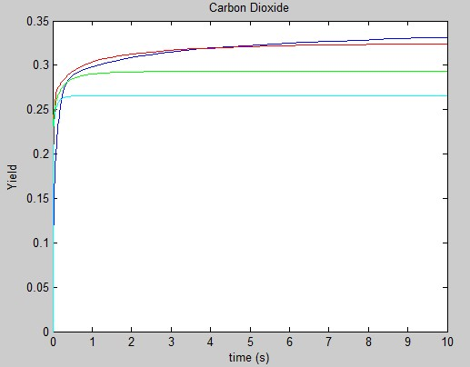

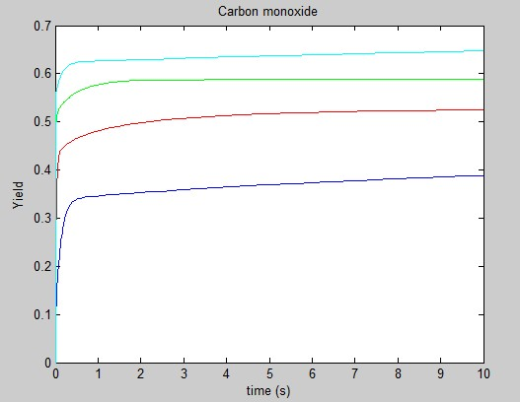

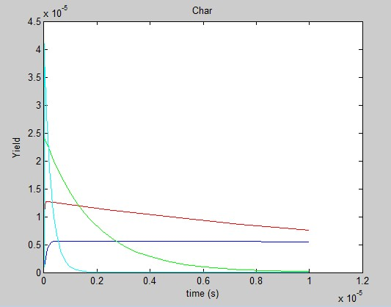

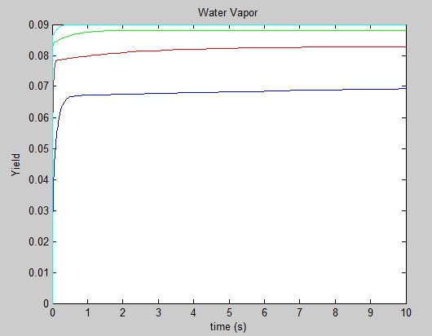

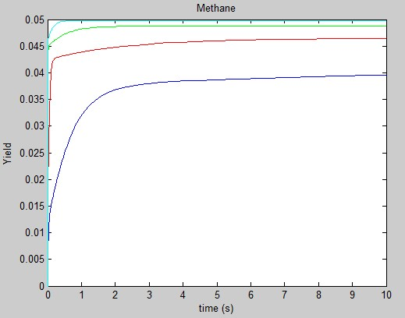

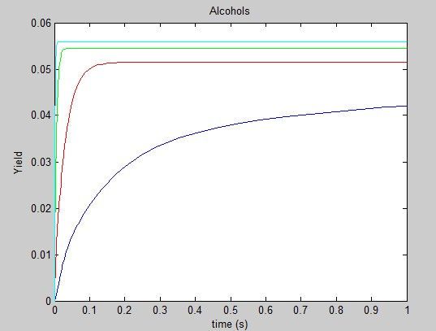

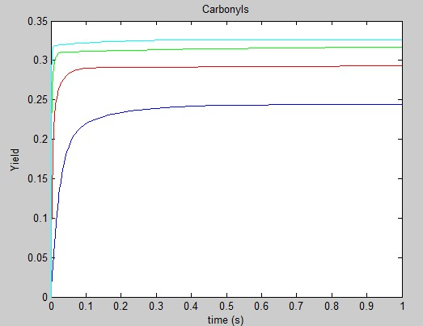

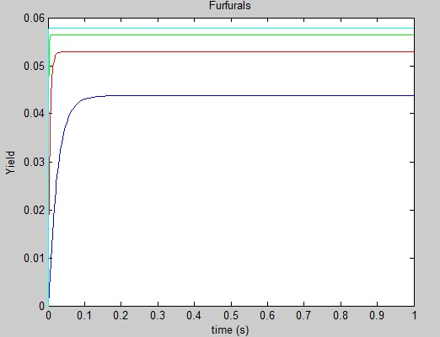

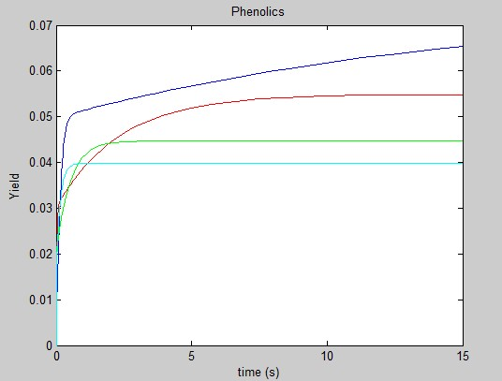

Unable to plot a graph with longer time span since MATLAB gives inaccurate results.

